Module A.1 – Level 0 Answers

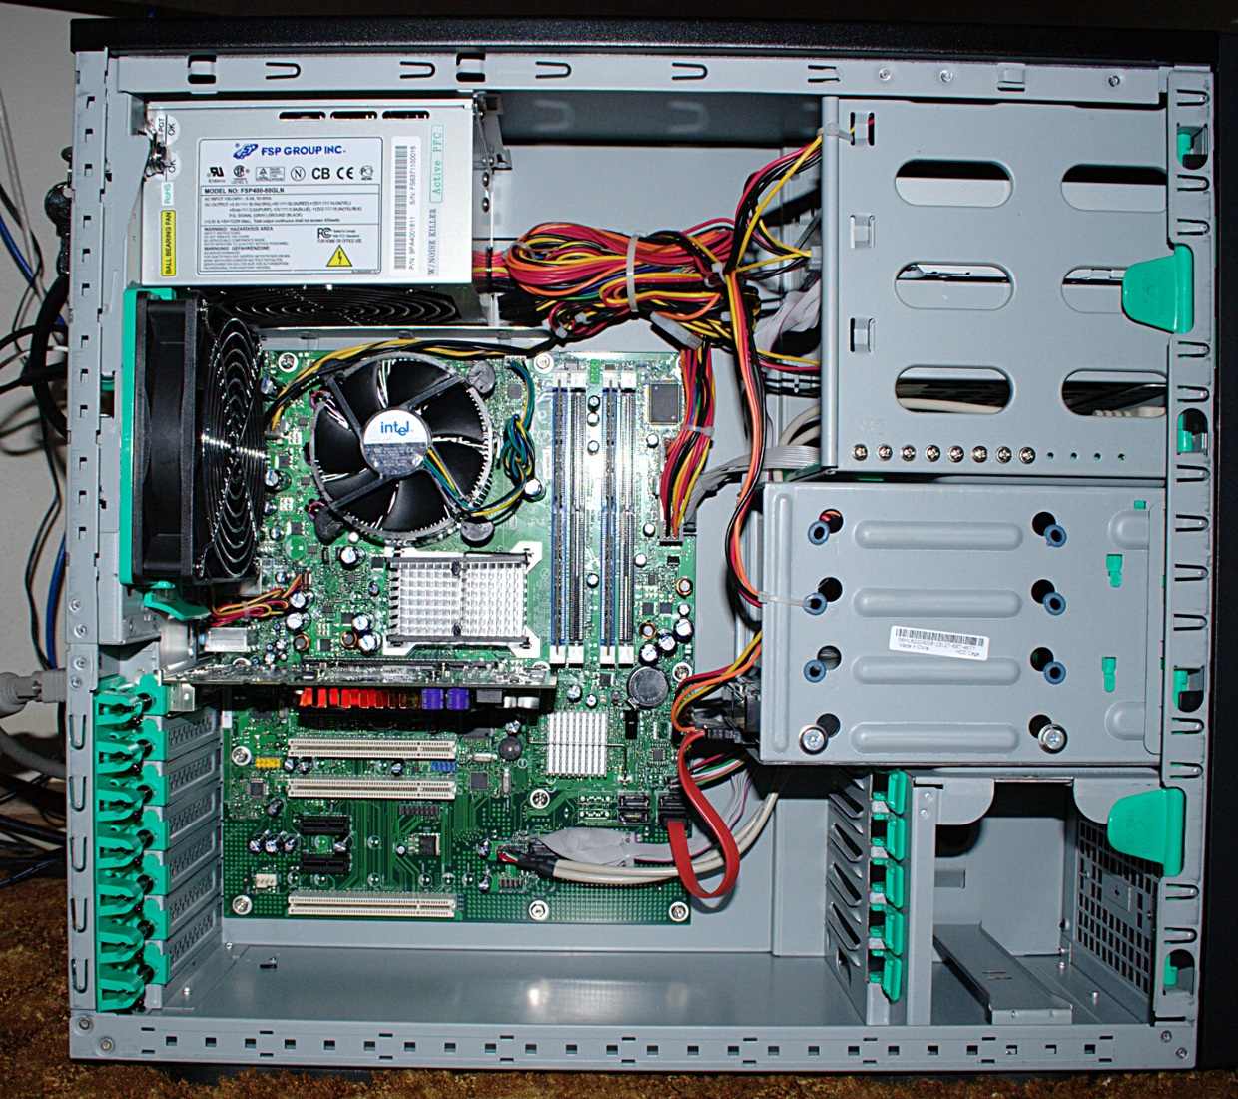

Hard Drive

CPU

Random Access Memory(RAM)

Power Supply Unit

Motherboard

Fan

<https://www.gcflearnfree.org/computerbasics/inside-a-computer/1/>

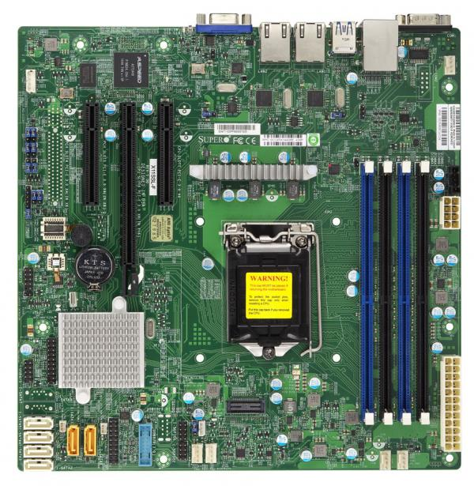

Voice and Sound board

Video, Sound, Ethernet/Wireless and USB devices

Memory Slots/ Ram Memory

CPU

Fan

CPU

SATA

PCI

BIOS

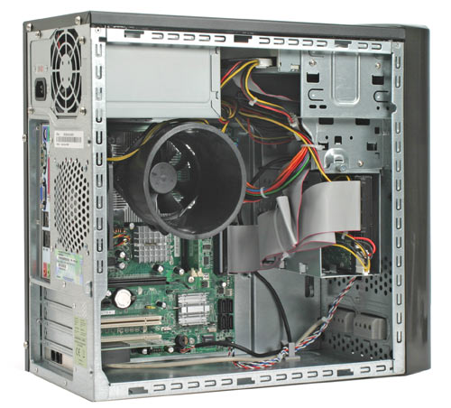

Power Supply cable to Motherboard

Hard Drive

Removable Media Drive

Hard Drive cable to Motherboard

External Connectors

Power Supply